What is an Ansible Variable?
An Ansible variable is a name that stores a value that you can use and reuse in your playbook.
For example:
vars:
package_name: httpd
Here:
package_name → variable name
httpd → variable value
We can use the variable in a task:
name: "{{ package_name }}"
Ansible replaces {{ package_name }} with httpd.

Simple meaning
Variable = A name used to store a value.

1. Valid Ansible Variable Names
A variable name should:
- Start with a letter or underscore
- Contain letters, numbers, and underscores
- Should not contain spaces
- Should not contain hyphens
- Should not start with a number

✅ Valid variable names
username
user_name
package_name
webserver1
server_port
_my_variable

❌ Invalid variable names
user-name # hyphen
user name # space
1username # starts with number
server.port # dot

Good practice
Use lowercase with underscores:
user_name: devops
package_name: httpd
service_name: httpd

2. Defining Variables
There are several places where you can define Ansible variables.
For beginners, start with:
- Playbook variables
- Group variables
- Host variables
Let's start with group variables, since that's what you asked for.

3. Group Variables
A group variable is a variable that applies to all hosts belonging to a particular inventory group.
Suppose your inventory is:
[dev1]
ansibleclient1
ansibleclient2
Both machines belong to the dev1 group.
We can create a group variable for dev1.

Directory structure
/home/ansible/
│
├── inventory
└── group_vars/
└── dev1.yml
Create the directory:
mkdir -p /home/ansible/group_vars
Create the variable file:
vi /home/ansible/group_vars/dev1.yml
Put:
package_name: httpd
Now package_name is available to all hosts in the dev1 group.

4. Use the Group Variable in a Playbook
Create:
vi install.yml
Put:
---
- name: Install package
hosts: dev1
become: true

tasks:
- name: Install web server
ansible.builtin.dnf:
name: "{{ package_name }}"
state: present
Notice:
name: "{{ package_name }}"
Ansible gets the value from:
group_vars/dev1.yml
which contains:
package_name: httpd
So Ansible effectively sees:
name: httpd

5. Why are Group Variables Useful?
Imagine you have:
[dev1]
ansibleclient1
ansibleclient2
ansibleclient3
And you define:
package_name: httpd
in:
group_vars/dev1.yml
Then all three machines get the same variable:
ansibleclient1 → package_name = httpd
ansibleclient2 → package_name = httpd
ansibleclient3 → package_name = httpd
You don't have to define the variable separately for every server.

Simple Diagram
Inventory
│
[dev1]
│
┌──────────┴──────────┐
↓ ↓
ansibleclient1 ansibleclient2
│ │
└──────────┬──────────┘
↓
group_vars/dev1.yml
│
package_name: httpd
│
↓
Available to both

Remember
Variable
↓
Stores a value

Group variable
↓
Variable applied to all hosts
in a particular inventory group
For your current inventory:
[dev1]
ansibleclient1
ansibleclient2
the group variable file should be:
group_vars/dev1.yml
because the inventory group is named dev1.
Yes. Let's run the group variable example step by step using your existing inventory /etc/ansible/hosts.

1. Your inventory
Check:
cat /etc/ansible/hosts
It should contain:
[dev1]
ansibleclient1
ansibleclient2

2. Create the group variable
Go to your Ansible project directory:
cd /home/ansible
Create the directory:
mkdir -p group_vars
Create the variable file:
vi group_vars/dev1.yml
Put:
package_name: apache2
Save with:
Esc
:wq
Enter
Your structure is now:
/home/ansible/
├── group_vars/
│ └── dev1.yml
└── install.yml

3. Create the playbook
vi install.yml
Put:
---
- name: Install package
hosts: dev1
become: true

tasks:
- name: Install web server
ansible.builtin.apt:
name: "{{ package_name }}"
state: present
update_cache: true
Here:
package_name
↓
group_vars/dev1.yml
↓
package_name: httpd
↓
Playbook uses "{{ package_name }}"
↓
Ansible installs httpd

4. Check the syntax
ansible-playbook -i /etc/ansible/hosts install.yml --syntax-check
You should get:
playbook: install.yml

5. Run the playbook
Now run:
ansible-playbook -i /etc/ansible/hosts install.yml

Since your ansibleclient1 and ansibleclient2 are Ubuntu, the Apache service name is apache2.

1. Playbook to START Apache
Create:
vi start-apache.yml
Put:
---
- name: Start Apache service
hosts: dev1
become: true

tasks:
- name: Start Apache
ansible.builtin.service:
name: apache2
state: started

Check syntax
ansible-playbook -i /etc/ansible/hosts start-apache.yml --syntax-check

Run
ansible-playbook -i /etc/ansible/hosts start-apache.yml

Verify
On the client:
systemctl status apache2
You should see:
Active: active (running)

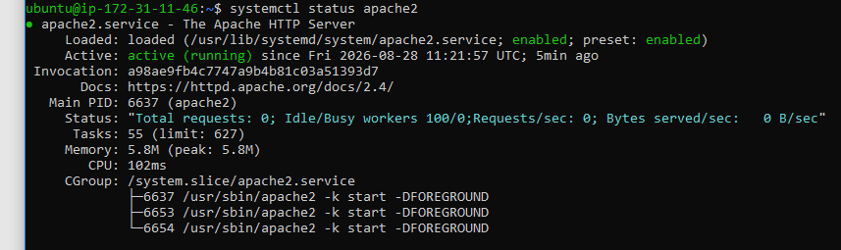

2. Playbook to STOP Apache
Create:
vi stop-apache.yml
Put:
---
- name: Stop Apache service
hosts: dev1
become: true

tasks:
- name: Stop Apache
ansible.builtin.service:
name: apache2
state: stopped

Check syntax
ansible-playbook -i /etc/ansible/hosts stop-apache.yml --syntax-check

Run
ansible-playbook -i /etc/ansible/hosts stop-apache.yml

Verify
systemctl status apache2
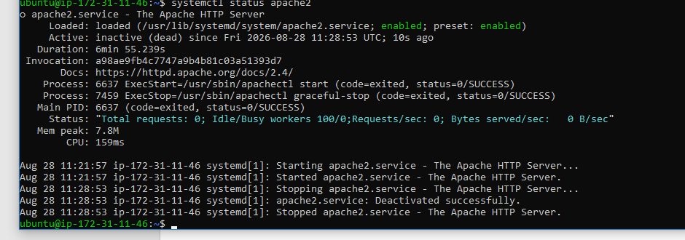

2) What is a Host Variable in Ansible?
A host variable is a variable that applies to only one specific host.
This is different from a group variable, which applies to all hosts in a group.

Simple difference
Group variable
↓
Applies to multiple hosts

Host variable
↓
Applies to one specific host
For example, your inventory is:
[dev1]
ansibleclient1
ansibleclient2
If you create a host variable for ansibleclient1, that variable applies only to ansibleclient1.

Defining a Host Variable
Host variables are commonly defined in a directory called:
host_vars/
The filename must match the hostname.
For your inventory:
ansibleclient1
ansibleclient2
your structure would be:
/home/ansible/
├── install.yml
├── group_vars/
│ └── dev1.yml
└── host_vars/
└── ansibleclient1.yml
Create the directory:
mkdir -p /home/ansible/host_vars
Create the variable file:
vi /home/ansible/host_vars/ansibleclient1.yml
Put:
web_port: 8080
Now:
web_port = 8080
is a host variable for ansibleclient1 only.

Small Example
Let's create a playbook that displays the variable.
Create:
vi host-variable.yml
Put:
---
- name: Demonstrate host variable
hosts: dev1
tasks:

- name: Display web port
ansible.builtin.debug:
msg: "The web port is {{ web_port }}"
Run:
ansible-playbook -i /etc/ansible/hosts host-variable.yml
Because web_port exists only for ansibleclient1, you will get something like:
ok: [ansibleclient1] => {
"msg": "The web port is 8080"
}
But ansibleclient2 will fail because it doesn't have the variable:
The task includes an option with an undefined variable.
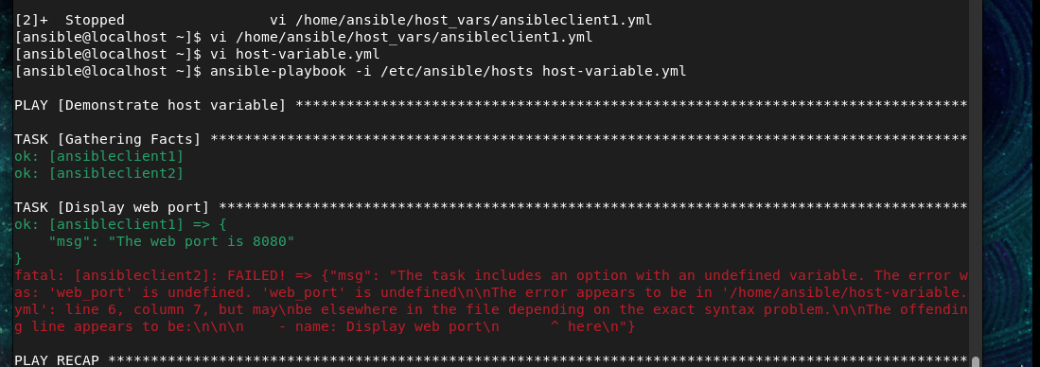

Better Example: Different Values for Different Servers
This is where host variables become very useful.
Suppose:
ansibleclient1 → web_port = 8080
ansibleclient2 → web_port = 9090
Create:
host_vars/
├── ansibleclient1.yml
└── ansibleclient2.yml

ansibleclient1.yml
web_port: 8080

ansibleclient2.yml
web_port: 9090
Then the same playbook:
---
- name: Show host-specific configuration
hosts: dev1

tasks:
- name: Display web port
ansible.builtin.debug:
msg: "The web port is {{ web_port }}"
will produce:
ansibleclient1 → The web port is 8080
ansibleclient2 → The web port is 9090
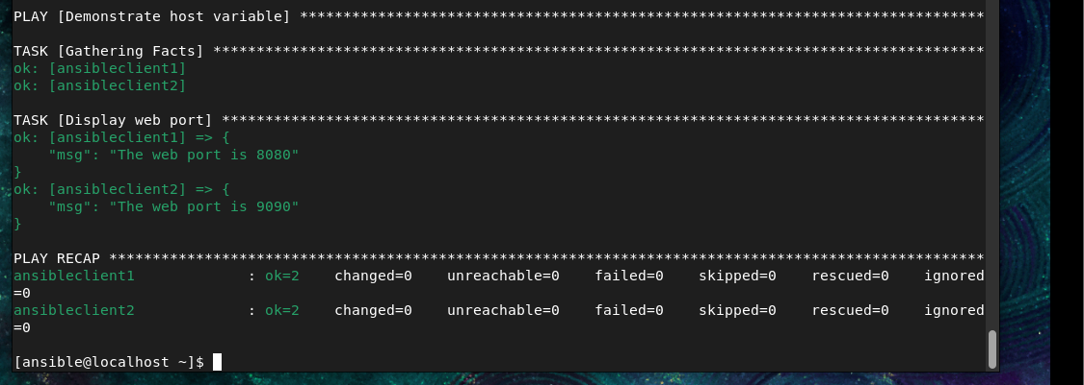

1. Defining Variables in an Ansible Playbook
A variable can be defined directly inside the playbook using the vars: section.

Example
---
- name: Define a variable
hosts: dev1

vars:
package_name: apache2

tasks:
- name: Display package name
ansible.builtin.debug:
msg: "The package is {{ package_name }}"
Here:
vars:
package_name: apache2
means:
Variable name → package_name
Variable value → apache2
We use the variable with:
"{{ package_name }}"

Run it
Save it as:
vi variable.yml
Then:
ansible-playbook -i /etc/ansible/hosts variable.yml
You should see:
The package is apache2

Simple meaning
Defining a variable = Creating a variable and assigning a value to it.

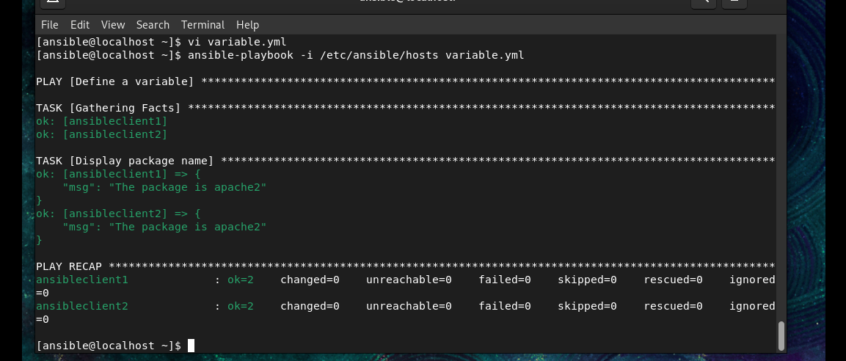

2. Overriding a Variable in Ansible
Overriding a variable means giving a variable a different value from its original value.
For example, suppose your playbook has:
vars:
package_name: apache2
Normally:
package_name = apache2
But you can override it when running the playbook:
ansible-playbook -i /etc/ansible/hosts variable.yml -e "package_name=nginx"
Now:
Original value → apache2
Override value → nginx
Ansible uses:
package_name = nginx

Example playbook
---
- name: Override variable example
hosts: dev1

vars:
package_name: apache2

tasks:
- name: Display package
ansible.builtin.debug:
msg: "Package is {{ package_name }}"
Normal run:
ansible-playbook -i /etc/ansible/hosts variable.yml
Output:
Package is apache2
Override it:
ansible-playbook -i /etc/ansible/hosts variable.yml -e "package_name=nginx"
Output:
Package is nginx
So:
Overriding = Replacing the existing value with another value.
-e means extra variables.

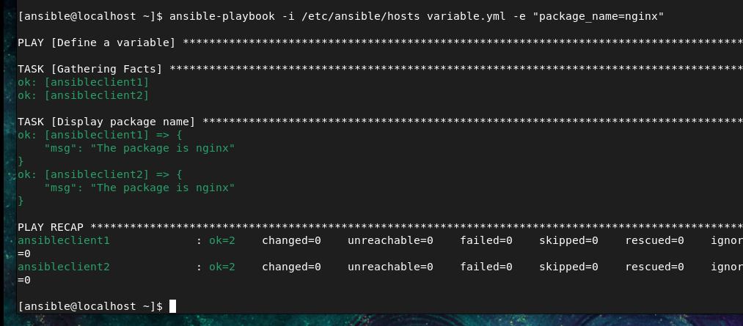

3. Using Dictionaries as Variables
A dictionary is a variable that contains multiple key-value pairs.
For example:
student:
name: Rahul
age: 25
course: Linux
Here:
student
│
├── name → Rahul
├── age → 25
└── course → Linux
This is useful when several pieces of information belong together.

Simple Ansible Example
Create:
vi dictionary.yml
Put:
---
- name: Dictionary variable example
hosts: dev1

vars:
student:
name: Rahul
age: 25
course: Linux

tasks:
- name: Display student name
ansible.builtin.debug:
msg: "Student name is {{ student.name }}"

- name: Display student course
ansible.builtin.debug:
msg: "Course is {{ student.course }}"
Run:
ansible-playbook -i /etc/ansible/hosts dictionary.yml
Output will be similar to:
Student name is Rahul
Course is Linux

